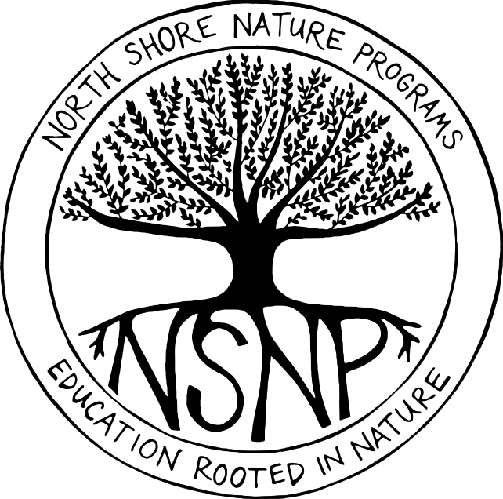
NORTH SHORE NATURE PROGRAMS

Assistant Counselor Job Description

ASSISTANT COUNSELOR
Job Description
The Assistant Counselor position is a full-time (40hr/wk) seasonal position. As assistant counselor, you will help plan and lead daily activities for campers ranging in age from 6-14 years old at a nature-based summer program. These programs emphasize exploration, group cooperation, nature study, and experiential learning. Activities could include: short hikes, fishing, shelter building, inclusive games, art, and nature crafting. Assistant counselors will be confident in their interactions with children, as well as parents, and will be eager to share their joy of nature with all program participants. Assistant counselors will work in conjunction with the Program Director and Lead Counselors to provide a safe and optimal experience for all children under their supervision.

Qualifications:
- Be at least 17 years of age.
- Experience working with children.
- Enthusiasm, creativity, and caring personality.
- Ability to communicate effectively with children, parents, and fellow staff members.
- Comfort working outside in all types of summer weather.
- Ability to hike 1-2 miles every day and have the physical capacity to participate in a variety of games and outdoor exploration activities.

Hours
Monday – Friday; 8am-4pm

Dates
Training Days: June 20-24
Camp Weeks: June 27-July 1
July 5-8
July 11-15
July 18-22
July 25-29
August 1-5
August 8-12
August 15-19
Wages
$12-13/hr based on experience. No benefits are available.

To Apply
Email cover letter, resume, and three references to Andrew Prazar: andrew@northshorenatureprograms.com

